Boys and men of color (BMoC) have tremendous, often untapped potential to contribute to our nation's economic vitality, global competitiveness, and innovation. Yet, this potential is significantly undermined by pressing mental and physical health inequities. Despite narrowing life expectancy gaps between men and women, BMoC are more likely to perish prematurely from preventable conditions. Masculinity norms play a role in the health behaviors contributing to poor health outcomes in BMoC. However, health inequities among BMoC are also rooted in exposures to broader social conditions including persistent structural and interpersonal racism. Addressing such conditions among BMoC, is particularly important as our nation moves through one of its most significant demographic transitions.

Division 51 has a longstanding commitment to and expertise in unpacking the myriad ways that gender, race, sexual orientation, and socioeconomic status impact the well-being of boys and men. Our division has led scholarly and advocacy efforts designed to enhance understanding of connections between diverse masculinities and health. Today, I am pleased to announce my intentions to build on these contributions and my 2020 Presidential Theme: **Holding Space for Boys & Men of Color: Reimagining Masculinities, Transforming Systems, Advancing Health Equity**.

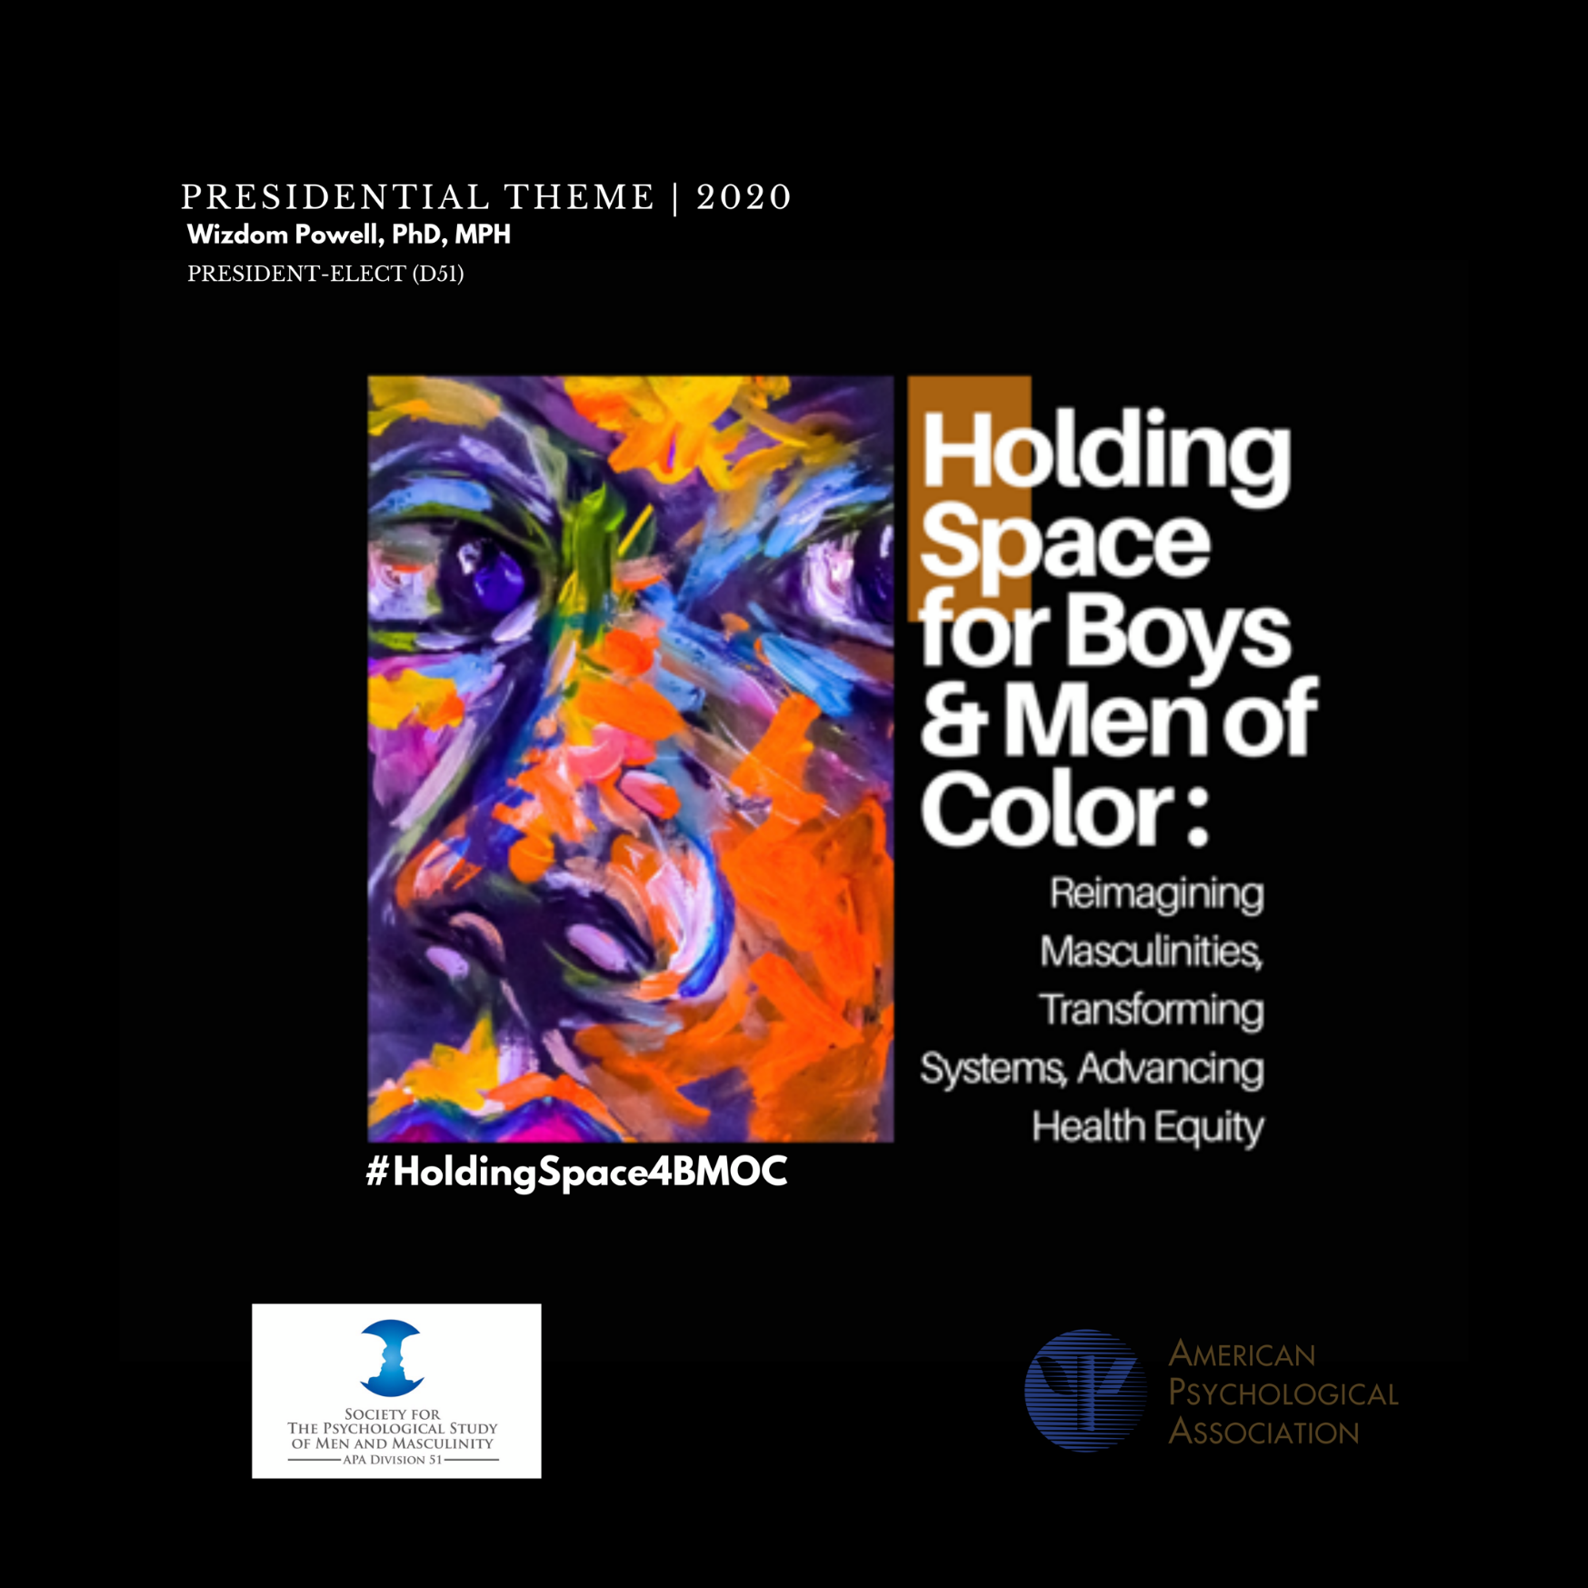

*Holding space for BMoC is about creating therapeutic landscapes where they live, work, play, pray, get educated, are confined, and get healthcare. Holding space is about shifting processes of care, addressing stereotypic masculinity norms that often create racially engendered barriers to help-seeking, and translating evidence into policy action. But, at its most basic level, holding space is about acknowledging the full range and depth of humanity among BMoC.*

Psychologists have a critical role to play in advancing social justice and health equity for BMoC. Advancing health equity among BMoC entails **reimagining masculinities**, **bridging longstanding empathy gaps**, and **transforming systems** so that when they are built, BMoC will come. However, accomplishing these outcomes requires trans-disciplinary and multi-sectoral approaches. Thus, I am pleased to announce the formation of my *Presidential BrainTrust for Health Equity among Boys & Men of Color*, a collection of the following nationally recognized experts:

**Michael Lindsey, PhD, MSW, MPH**

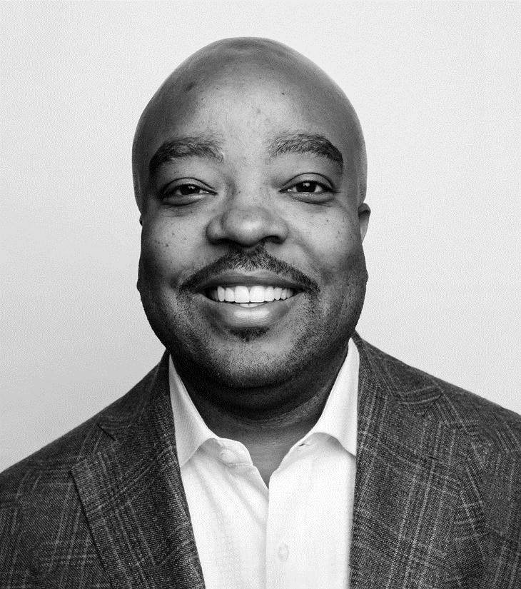Dr. Michael A. Lindsey is a noted scholar in the fields of child and adolescent mental health, as well as a leader in the search for knowledge and solutions to generational poverty and inequality. He is the Executive Director of the McSilver Institute for Poverty Policy and Research at New York University (NYU), the Martin Silver Professor of Poverty Studies at NYU Silver School of Social Work, and an Aspen Health Innovators Fellow. He also leads a university-wide Strategies to Reduce Inequality initiative from the McSilver Institute.

At McSilver, Dr. Lindsey leads a team of researchers, clinicians, social workers and other professionals who are committed to creating new knowledge about the root causes of poverty, developing evidence-based interventions to address its consequences, and rapidly translating their findings into action through policy and best practices.

Among their latest work is a three-year research grant from the National Institute of Mental Health to study the effectiveness of a novel treatment intervention for keeping Black adolescents engaged in depression treatment.

Prior to joining NYU Silver in 2014, Dr. Lindsey was an Associate Professor at the University of Maryland School of Social Work and a Faculty Affiliate at the University of Maryland Department of Psychiatry’s Center for School Mental Health.

Dr. Lindsey is a standing member of Center for Substance Abuse Prevention (CSAP) National Advisory Council at the Substance Abuse and Mental Health Services Administration. He also is on the editorial board of the journal Administration and Policy in Mental Health and Mental Health Services Research. He holds a PhD in social work and MPH from the University of Pittsburgh, an MSW from Howard University, and a BA in sociology from Morehouse College.

**Art Blume, PhD**

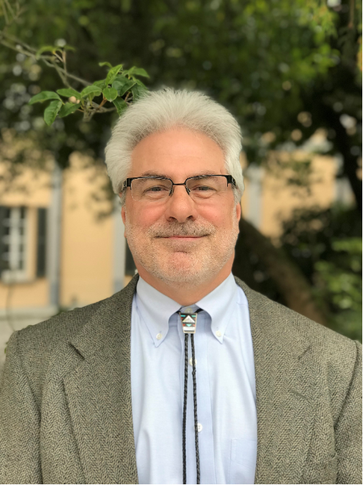Art Blume, an American Indian psychologist and scholar, is currently Professor of Clinical Psychology at Washington State University and President-elect of APA Division 45. He has been honored with the Joseph E. Trimble and Jewell E. Horvat Award for Distinguished Contributions to Native and Indigenous Psychology, a Rockefeller Foundation Academic Writing Fellowship, an appointment as President’s Professor at the University of Alaska Fairbanks Center for Alaska Native Health Research, and as APA fellow in Divisions 45 and 50. He has also served as President of the Society of Indian Psychologists, as Associate Editors of the journals *Cultural Diversity and Ethnic Minority Psychology* and *Addictive Behaviors*, and as a member of the American Psychological national work group on health disparities in boys and men. Dr. Blume recently edited the three volume book series published by Praeger entitled, *Social issues in living color: Challenges and solutions from the perspective of ethnic minority psychology,* and is currently writing a new book entitled, *A new psychology based on community, equality, and care of the Earth: An Indigenous American perspective*, to be published by Praeger in 2020.

**Hector Y. Adames, PhD**

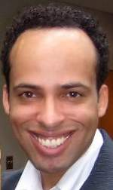Dr. Hector Y. Adames is a neuropsychologist, an Associate Professor at The Chicago School of Professional Psychology, Chicago Campus, and the Co-Director of the IC-RACE Lab (**I**mmigration **C**ritical **R**ace **A**nd **C**ultural **E**quity Lab). He co-authored a textbook on Latinxs in the United States titled, *Cultural Foundations and Interventions in Latino/a Mental Health: History, Theory and within Group Differences* published by Routledge Press. His research focuses on how socio-race, skin-color, colorism, and ethnic and racial group membership influence wellness. He has earned several awards including the 2018 Distinguished Professional Early Career Award from The Society for the Psychological Study of Culture, Ethnicity, and Race, a Division of the American Psychological Association (APA).

**Jacqueline Mattis, PhD**

Jacqueline S. Mattis is Professor of Psychology and Associate Chair for Diversity Initiatives at the University of Michigan. Her work explores the meanings, manifestations, and functions of religiosity and spirituality among African American and Afri-Caribbean youth and adults—particularly urban-residing youth and adults. Of particular concern is the link between religiosity, spirituality and positive psychological as well as prosocial outcomes among African American and Afri-Caribbean youth and adults. In this line of work she investigates the ways in which people conceive of God, how they express religious and spiritual commitment, and how they use their faith to guide decisions and behaviors. She examines the extent to which, and ways in which, various domains of religiosity and spirituality (e.g., people’s self-definition as religious and or spiritual, involvement in formal and public aspects of religious life) inform such positive outcomes as forgiveness, empathy, compassion, altruism, volunteerism, and community involvement among those who live with the challenges associated with urban life.

A recent line of work, conducted with collaborators Dr. Christine McWayne (Tufts University) seeks to understand how low-income, urban-residing African American, Afri-Caribbean, and African immigrant parents of preschoolers conceive of and assess supportive or positive parenting. This measurement study, funded by the National Institutes of Health, used parent conversation groups, individual interviews, and videotaped observations of dyadic play interactions between parents and their children to identify the goals, values and practices associated with positive parenting. Most recently she has been engaged in research on the experiences of love, compassion and dignity among urban residing Black men and women.

Dr. Mattis is the co-author (with Fulya Kurter, Bahçesehir University) of two published scholarly books on culture and counseling from the experience of Turkish mental health practitioners.

**Derek Griffith, PhD**

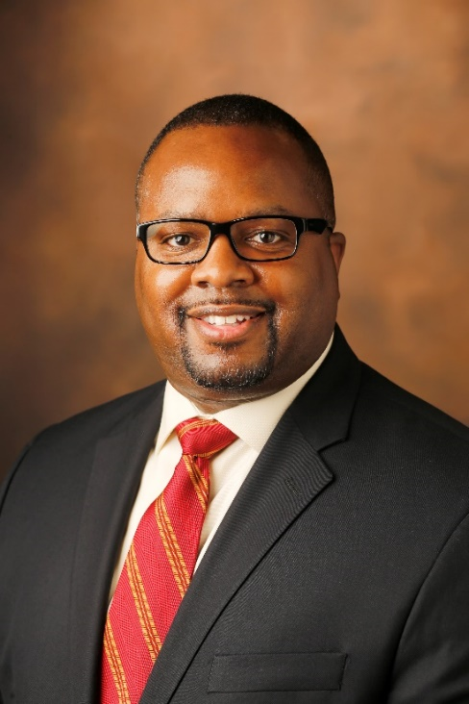Dr. Derek M. Griffith is Professor of Medicine, Health and Society, and he is the Founder and Director of the Center for Research on Men’s Health at Vanderbilt University. Dr. Griffith also has affiliate appointments in American Studies, Health Policy, Human and Organizational Development, and Sociology at Vanderbilt, and he is the chair of the Tennessee Men’s Health Report Card.

Trained in psychology and public health, Dr. Griffith has developed a program of research that focuses on developing and implementing behavioral and policy strategies to achieve equity in health and well-being. He has been a leader in three areas: (a) applying the concepts of intersectionality and manhood to men’s health; (b) developing and testing precision lifestyle medicine interventions to prevent and reduce the impact of obesity, cancer, diabetes and cardiovascular disease among African American men and other groups of men; and (c) conceptualizing institutional racism, men’s health disparities, and men’s health equity. His research has been featured on *NPR* and in *Ebony*, *Time*, *USA Today*, and numerous other national media outlets.

Dr. Griffith is a contributor to and editor of two books: *Men’s Health Equity* (Routledge, 2019), the first book to describe unjust yet modifiable differences among men in the United States and across the world, and *Racism: Science and Tools for the Public Health Professional* (APHA Press, 2019), which offers insight and strategies to identify and address racism in various public health roles and settings. He is a member of the editorial boards of several men’s health and public health journals, and has been a guest editor of seven journal special issues or supplements on aspects of men’s health, health equity and men’s health equity. Dr. Griffith has co-authored or provided expert review of reports from the American Psychological Association, Promundo-US, and the World Health Organization.

Dr. Griffith been the principal investigator of over 4-million dollars in research grants and co-investigator of over 26-million dollars in research grants from the American Cancer Society, the Robert Wood Johnson Foundation, other foundations, and several institutes within the National Institutes of Health. Dr. Griffith has collaborated with colleagues in Canada, Ireland, New Zealand and the United States on various research projects on health equity, men’s health, institutional racism in public health, and racism as a determinant of health. Currently, Dr. Griffith is conducting three studies: (a) Mighty Men, the first individually tailored, faith-based weight loss study specifically designed for African American men; (b) Tailor Made, the first weight loss intervention for African American and Latino men that seeks to incorporate individual psychological and biological factors; and (c) Engendering Trust in Health Care, which aims to create a new measure to increase African American men’s trust in health care by incorporating gender, age and race.

Dr. Griffith was given the Tom Bruce Award by the Community-Based Public Health Caucus of the American Public Health Association in recognition of his leadership in community-based public health and for his research on “eliminating health disparities that vary by race, ethnicity and gender”. In addition, he was named a Fellow of the American Academy of Health Behavior for significant contributions to the field of health behavior research.

**David Ikard, PhD**

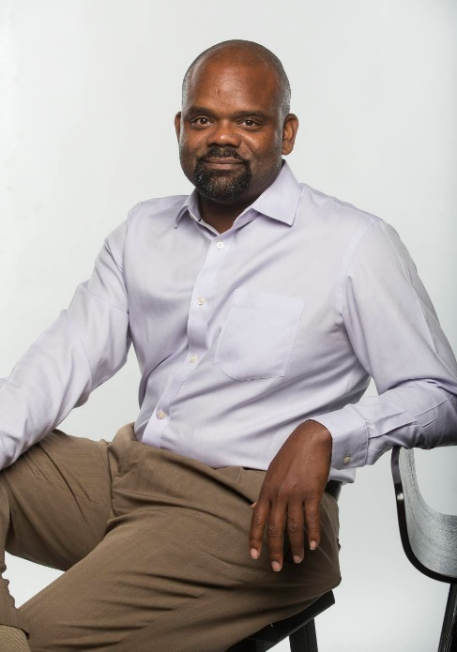David Ikard is professor of African American and Diaspora Studies at Vanderbilt University. He has authored four books, including Breaking The Silence: Toward a Black Male Feminist Criticism, Nation of Cowards: Black Activism in Barack Obama's Post-Racial America (co-authored with Martell Teasley), Blinded by the Whites: Why Race Still Matters in the 21st Century and *Lovable Racists, Magical Negroes, and White Messiahs* (2017). In 2013 *Nation of Cowards* received the Best Scholarly Book Award from the DIOP organization. His essays have appeared in African American Review, MELUS, Palimpsest, African and Black Diaspora Journal, The Journal of Black Studies, and Obsidian III. In 2015 he received the William R. Jones Outstanding Mentor Award from the Florida Education Fund and the McKnight Fellows for his dedication and commitment to mentoring graduate students. He is also a Ford Fellow and a faculty mentor for the Woodrow Wilson Career Enhancement Fellowship. His new painting series, entitled “I Am A Man,” extends his scholarly investigations into black masculinity into the creative realm. More specifically, he renders the complexity of black boys and men’s humanity beyond dehumanizing stereotypes to call attention to their social vulnerability and plight.

**Y. Joel Wong, PhD**

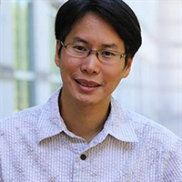Joel Wong, Ph.D. is a Professor of Counseling Psychology and Chair of the Counseling & Educational Psychology Department at Indiana University. Dr. Wong is a fellow of the American Psychological Association through Divisions 17, 45, and 51 and of the Asian American Psychological Association. His research interests are in the psychology of men and masculinities, positive psychology, and Asian American mental health. Dr. Wong is the co-editor of two books on men and masculinities – the APA Handbook of Men and Masculinities (with Dr. Stephen Wester) and the Psychology of Men and Masculinities (with Dr. Ron Levant). He is also an associate editor for the journal, Psychology of Men and Masculinities.

**Debra Furr-Holden, PhD**

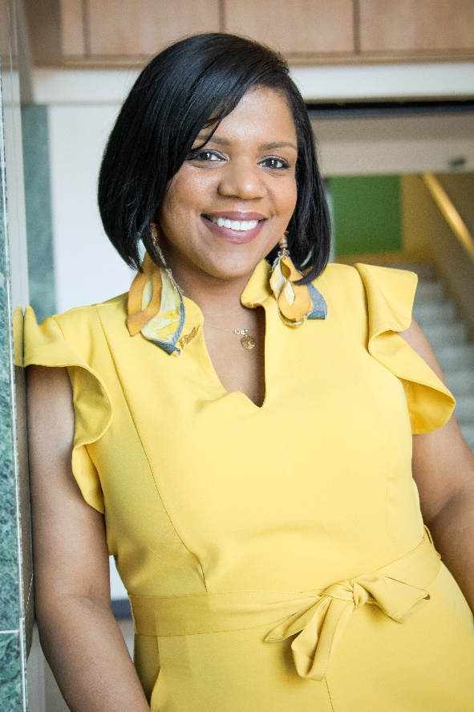Dr. Debra Furr-Holden is the Associate Dean for Public Health Integration, and C.S. Mott Endowed Professor and Director of the Division of Public Health at the Michigan State University. She is also the Director of the Flint Center for Health Equity Solutions, funded by the National Institute on Minority Health and Health Disparities (#U54MD011227). She is an epidemiologist and classically-trained public health professional with expertise in behavioral health equity, drug and alcohol dependence epidemiology, psychiatric epidemiology, and prevention science. Dr. Furr-Holden has worked extensively with a wide range of partners including community-based organizations, local municipal officials, and policy makers. Her research has supported legislative efforts to impact state- and national-level legislation to promote behavioral health equity. Dr. Furr-Holden’s community-based, action-oriented research has been well received by community stakeholders and driven multiple policy interventions to address some of the nation’s greatest public health challenges, especially among African-American and in racially segregated communities. Dr. Furr-Holden’s research is grounded in the rubrics of epidemiology and consistent with principles and practices for understanding social determinants of health and health equity. Dr. Furr-Holden attended the Johns Hopkins University Krieger School of Arts and Sciences (BA Natural Sciences and Public Health, 1996) and Johns Hopkins Bloomberg School of Public Health (PhD, 1999).

**Rashawn Ray, PhD**

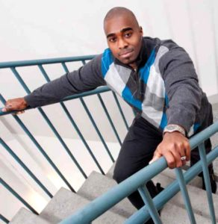**Dr. Rashawn Ray**is Associate Professor of Sociology and Executive Director of the Lab for Applied Social Science Research (LASSR) at the University of Maryland, College Park. He is also one of the co-editors of *Contexts Magazine: Sociology for the Public*. Formerly, Ray was a Robert Wood Johnson Foundation Health Policy Research Scholar at the University of California, Berkeley. Currently, he is a Rubenstein Fellow at the Brookings Institute.

Ray’s research addresses the mechanisms that manufacture and maintain racial and social inequality with a particular focus on police-civilian relations and men’s treatment of women. His work also speaks to ways that inequality may be attenuated through racial uplift activism and social policy. Ray has published over 50 books, articles, and book chapters, and 15 op-eds. Recently, Ray published the book *How Families Matter: Simply Complicated Intersections of Race, Gender, and Work* (with Pamela Braboy Jackson) and another edition of *Race and Ethnic Relations in the 21st Century: History, Theory, Institutions, and Policy*, which has been adopted nearly 40 times in college courses.

Ray has written for *New York Times, Huffington Post*, *NBC News*, *The Conversation, and* *Public Radio International*. Selected as 40 Under 40 Prince George's County and awarded the 2016 UMD Research Communicator Award, Ray has appeared on *C-Span*, *MSNBC*, *HLN, Al Jazeera, NPR,* and *Fox*. His research is cited in *CNN, Washington Post, Associated Press, MSN, The Root*, and *The Chronicle.* Previously, Ray served on the 50th Anniversary of the March on Washington Planning Committee and the Commission on Racial Justice with Alpha Phi Alpha Fraternity, Inc.

**Wizdom Powell, PhD, MPH**

**APA Division 51 President**

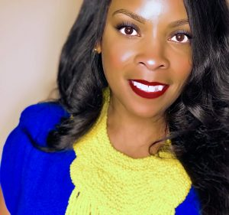Wizdom Powell is Director of the Health Disparities Institute and Associate Professor of Psychiatry at UConn Health. Formerly, Dr. Powell was Associate Professor at Health Behavior at UNC-Chapel Hill’s Gillings School of Global Public Health and Research Associate Professor in UNC’s Department of Social Medicine. Dr. Powell also served as Associate Director of the Center for Health Equity Research, faculty member at UNC’s Lineberger Comprehensive Cancer Center, and Director of the UNC’s Men’s Health Research Lab.

In 2011-2012, she was appointed by President Obama to serve as a White House Fellow to Secretary of Defense Leon Panetta. In this role she provided subject matter expertise on Military Mental Health (e.g., PTSD, Suicide, and Military Sexual Trauma). Her community-based research focuses on of the role of modern racism and gender norms on African American male health outcomes and healthcare inequities. She has published numerous peer-reviewed articles and book chapters including ones in the American Journal of Public Health, Journal of General Internal Medicine, Behavioral Medicine, and Child Development.

In addition to being a White House Fellow, she is an American Psychological Association (APA) Minority, Robert Wood Johnson Foundation, Kaiser Permanente Burch, Institute of African American Research, and Ford Foundation Fellow who received a Ph.D. and M.S. in Clinical Psychology and M.P.H. from the University of Michigan-Ann Arbor. She serves as chair of the APA’s workgroup on Health Disparities in Boys and Men and co-chair of the Health Committee for President Obama’s My Brother’s Keeper Initiative in Durham County.

In recognition of her public service to boys and men, she received the American Psychological Association’s (D51) Distinguished Professional Service Award. In 2015, she received the prestigious Phillip and Ruth Hettleman Prize for Outstanding Artistic and Scholarly Achievement by Young Faculty. Dr. Powell was awarded a 2017 academic writing residency at the Bellagio Center from the Rockefeller Foundation. During this highly competitive residency, Dr. Powell will work with other global leaders on strategies for transforming social and healthcare system landscapes to address gendered health Inequities among vulnerable males. Most recently, she was selected as a Health Innovator Fellow by the Aspen Institute.

Over the course of the next year, the *BrainTrust* will provide advice, input, and guidance on achieving short and long-term goals:

* Disrupting single public and scientific stories about BMoC, masculinities, and health outcomes
* Creating more strategy alignment across care delivery systems serving BMoC
* Developing health equity advocacy and policy communication tools for BMoC and community stakeholder leaders
* Building bridges with other disciplinary leaders and decision makers

We look forward to a productive and enriching year of **scholarship**, **service**, and **advocacy**.

Wizdom Powell, PhD, MPH

2020 President

Division 51

Society for the Psychological Study of Men & Masculinities